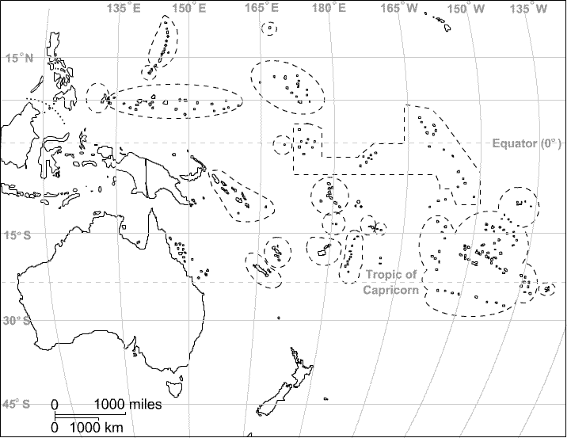Australia & Oceania

**Locate the following:**

American Samoa

Australia

Fiji

French Polynesia

Guam

Kiribati

Marshall Islands

Micronesia

Nauru

New Caledonia

New Zealand

Northern Mariana Islands

Palau

Papua New Guinea

Pitcairn Island

Samoa

Solomon Islands

Tonga

Tuvalu

Vanuatu

Wake Island

Wallis & Futuna