Middle East
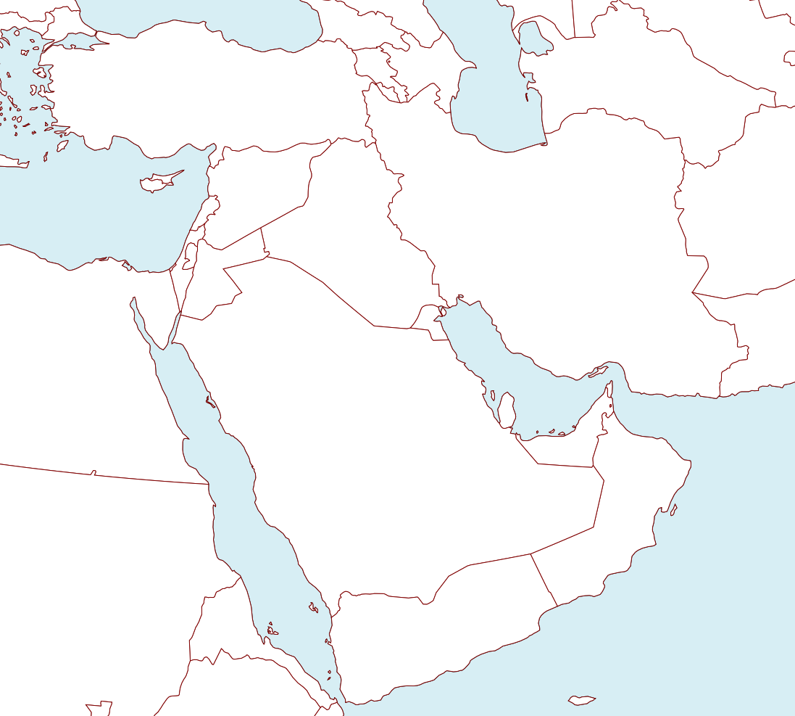

Practice at: http://www.sheppardsoftware.com/Middle-east_Geography.htm or tinyurl.com/yfmgud3
Countries:

Bahrain
Cyprus
Golan Heights
Iran
Iraq
Israel
Jordan
Kuwait
Lebanon
Oman
Palestinian Territories
Qatar
Saudi Arabia
Syria
Turkey
United Arab Emirates
Yemen

Bodies of Water:
Persian Gulf
Red Sea

Gulf of Oman
Gulf of Aden

Caspian Sea
Mediterranean Sea

