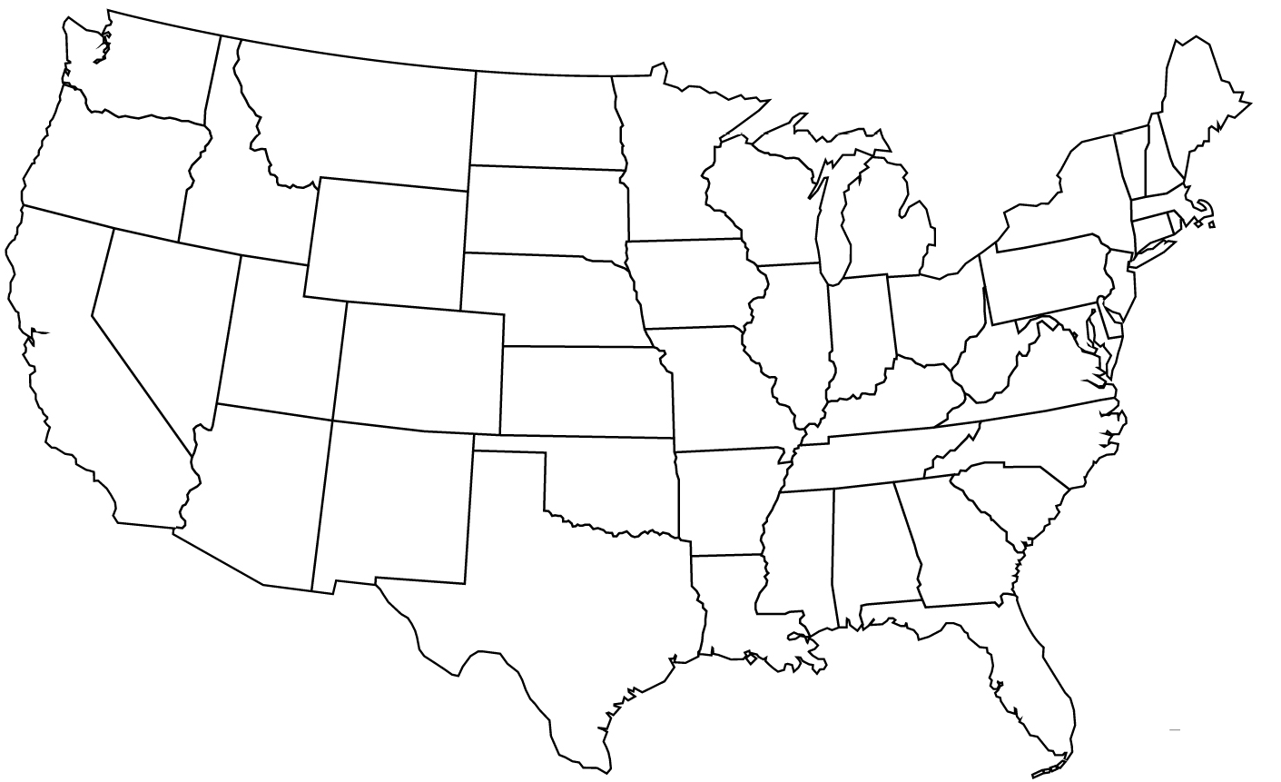
Louisiana Purchase Mapping Exercise

- Put a star where we live on the map
- Draw a blue line down the Mississippi River
- Circle New Orleans
- Use a different color to show the United States before the Louisiana purchase
- Color in the Louisiana Purchase area
- What was the price Jefferson paid for the Louisiana Territory? _____________________
- Draw the route the Lewis and Clark expedition took to the West Coast. Label the city where they started.
- How many states did Lewis and Clark travel through? ____________________________
- How far did Lewis and Clark travel round trip? _________________________________
- How long did it take Lewis and Clark to reach the Pacific Ocean? __________________
- In which general direction did Lewis and Clark travel on their journey? ______________

