Critical Thinking Skills
Distinguishing Fact from Opinion
Primary sources – such as letters, diaries, and speeches – often express the opinions of the people who wrote them. Therefore, when historians study primary sources, they have to distinguish fact from opinion. A fact is something that can be proved or observed. An opinion is a judgement that reflects a person’s beliefs or feelings. It may not always be true.
In the letter below, Alexander Hamilton writes about political differences between himself and the party led by James Madison and Thomas Jefferson. Like many writers, Hamilton combines fact and opinion. Read the letter and distinguish fact from opinion.
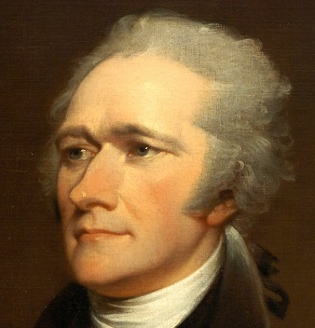

Alexander Hamilton wrote:
“It was not until the last session of Congress that I became completely convinced that Mr. Madison and Mr. Jefferson are at the head of a faction that is hostile toward me. They are motivated by views that, in my judgement, will undermine the principles of good government and are dangerous to peace and happiness of the country.
Freneau, the present publisher of National Gazette, was a known Antifederalist. It is certain that he was brought to Philadelphia by Mr. Jefferson to be the publisher of a newspaper. At the same time as he was starting his paper, he was also a clerk in the Department of State. His paper is devoted to opposing me and the measures that I have supported. And the paper has a general unfriendly attitude toward the government of the United States.
On almost all questions, great and small, which have come up since the first session of Congress, Mr. Jefferson and Mr. Madison have been found among those who want to limit federal power. In respect to foreign policy, the views of these gentlemen are, in my judgement, equally unsound and dangerous. They have a womanish attachment to France and a womanish resentment against Great Britain.”

Determine which statements are facts. Remember that facts can be proved. Use your reading in this chapter to help answer these questions.
- Find two statements of fact in Hamilton’s letter

- How can you prove that each statement is fact?

Determine which statements are opinions. Writers often show that they are expressing an opinion by saying “in my view” or “I think” or “I believe.”
- Find two statements in which Hamilton gives his opinion.

- How can you tell that each is an opinion?

Determine how a writer mixes fact and opinion. Reread the last sentence of the letter.
- What did Hamilton mean by a “womanish attachment to France and a womanish resentment against Great Britain”?

- Is it true that Jefferson supported France and Opposed Britain?

- What country did Hamilton want the United States to support?

- Why do you think Hamilton mixed fact and opinion in the statement?

