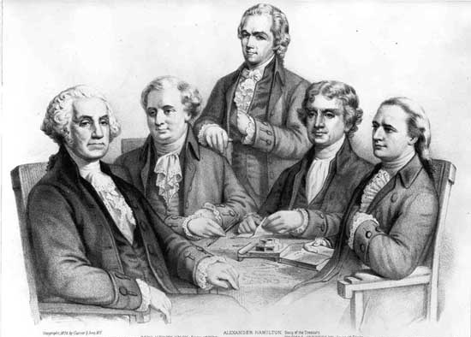
President Washington worked with the first Congress to organize the daily operation of the new national government. In Chapter Eight, we read how members of Washington’s Cabinet were chosen, how a federal court system was set up, and how plans for paying the national debt and strengthening the nation’s finances were created.

Instructions: Work with your group to prepare one of the following dialogues. Be thorough in your response. Consider the internal and external pressures within each scenario. Your dialogue should be at least one page long. You will share with the class. (Make sure to record the names of all group members)

Scenario One: A dialogue between Alexander Hamilton and James Madison on paying national and state debts.

Scenario Two: A dialogue between Alexander Hamilton and a southern member of Congress on passing a tariff.

Scenario Three: A dialogue between Alexander Hamilton and George Washington on dealing with the leaders of the Whiskey Rebellion.

