The United States Constitution  The Preamble Translation  by __________________ | This Preamble is the introduction of the Constitution. It explains why the Constitution was created.  We the People of the United States, in Order to form a more perfect Union, establish Justice, insure domestic Tranquility, provide for the common defense, promote the general Welfare, and secure the Blessings of Liberty to ourselves and our Posterity, do ordain and establish this Constitution for the United States of America.  But…what does it mean? Translate each of the following pieces taken from the preamble, by writing it in a way that makes sense to you. Then, draw a quick picture to accompany your writing in each of the boxes. | We the People of the United States,
in Order to form a more perfect Union, | establish Justice, | insure domestic Tranquility,
provide for the common defense, | promote the general Welfare, | and secure the Blessings of Liberty to ourselves
and our Posterity, | do ordain and establish this Constitution  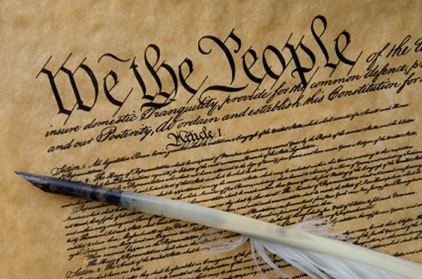  Americans decided to write the constitution. | for the United States of America.

