Ancient Greece & Geography

Use the maps on pages 235 & 241 of your text book to complete the following activity

Label the following bodies of water and then color them blue.
- Adriatic Sea
- Ionian Sea
- Mediterranean Sea
- Sea of Crete
- Aegean Sea
- Sea of Marmara
Label the following places by putting a black dot and their name at each location
- Olympia
- Athens
- Sparta
- Thermopylae
- Crete
- Corinth
- Marathon
- Mt. Olympus
What feature do you notice is missing from Greece that has so far been found in all the other ancient civilizations we’ve studied?
_________________________________________________________________________________________
How do you think Greece has survived without this feature?
________________________________________________________________________________________
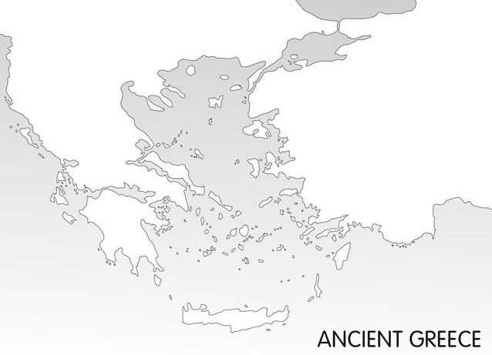
Greece has a pleasant climate. Most of the rainfall occurs during the winter months. Summers are hot and dry. Average temperatures in Greece are about 50 degrees in the coldest months and 90 degrees during the warmest months, making this region an easy place to be outside, even year round. Draw a symbol on the right hand side of the map to represent Greece’s climate.

