Election of 1860 Campaign Speech
Assignment:
The year is 1860 and the nation is on the brink of division and war. You work on a campaign for one of four candidates for the presidency of the United States of America. Your job is to write a brief campaign speech for the candidate you have been assigned to work for. As a speech writer, you are charged with helping your candidate strike the right tone and secure the most votes while not compromising their own values and ideology. Your candidate is planning on delivering a speech at a campaign rally tonight and you only have an hour or two to come up with an inspired speech. Speeches should between 300-400 words.
YOUR SPEECH MUST MAKE REFERENCE AND INCLUDE YOUR CANDIDATE’S OPINION OF EACH OF THE FOLLOIWNG:
ISSUES
- Compromise of 1850, including the changes made to strengthen the Fugitive Slave Law
- Publishing and popularization of the book Uncle Tom’s Cabin, 1852
- Kansas-Nebraska Act - 1854
- Problems in “Bleeding Kansas” - 1856
- Dred Scott Case - 1857
- John Brown’s Raid on Harper’s Ferry - 1859
*What would your candidate have thought about each of the events listed above? Remember to consider the background and party of the candidate assigned to you. Outside research will be necessary. Please cite any sources consulted.
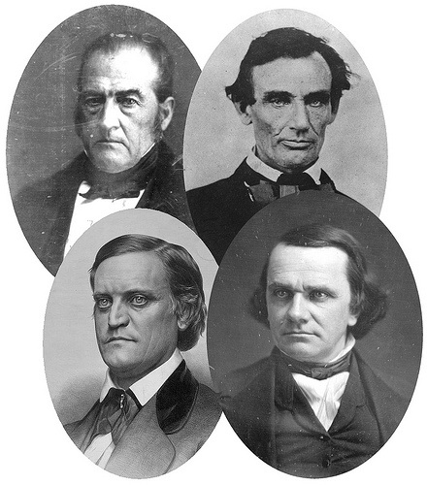
CANDIDATES
- Abraham Lincoln
- Stephen Douglass
- John Breckenridge
- John Bell

