Asia Map
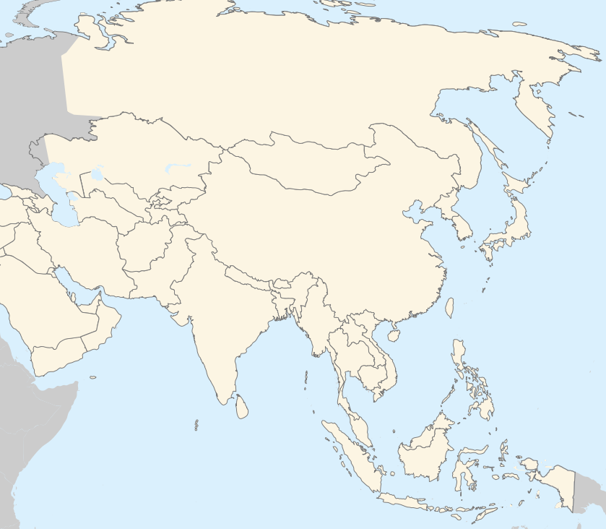

Practice online at http://www.sheppardsoftware.com/Asian_Geography.htm (or use this shorter url: http://tinyurl.com/3lry8p)
Identify the following:

Afghanistan
Arabian Sea
Armenia
Azerbaijan
Bangladesh
Bay of Bengal
Bhutan
Brunei
Cambodia
China
East China Sea
Georgia
India
Indian Ocean
Indonesia
Japan
Kazakhstan
Kyrgyzstan
Laos
Malaysia
Mongolia
Myanmar
Nepal
North Korea
Pacific Ocean
Pakistan
Philippine Sea
Philippines
Russia
Sea of Japan
Singapore
South China Sea
South Korea
Sri Lanka
Taiwan
Tajikistan
Thailand
Turkmenistan
Uzbekistan
Vietnam
Yellow Sea

