AFRICA
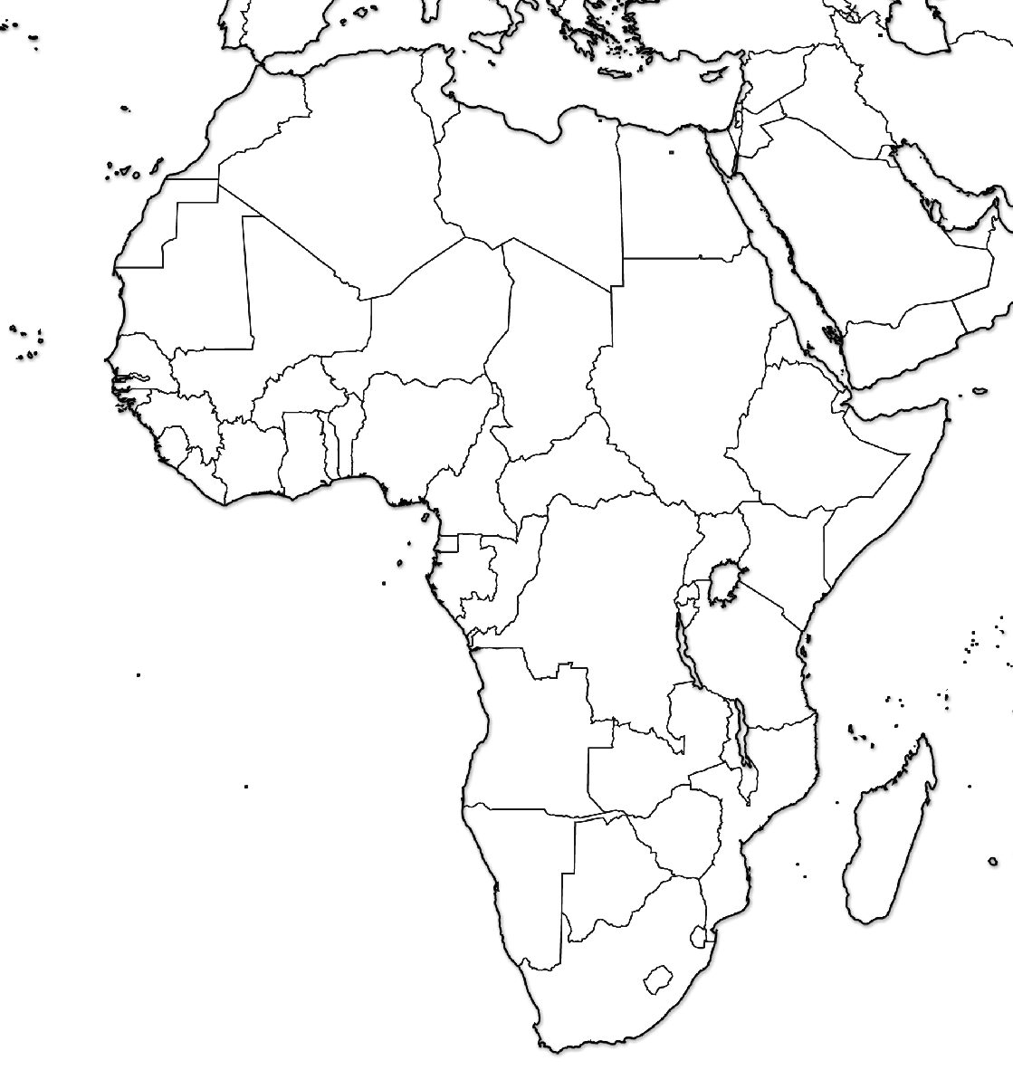
Quiz with maps is Friday, November 19. Test without maps is Friday, December 2.
Practice online: http://www.sheppardsoftware.com/African_Geography.htm or http://tinyurl.com/64987
Identify:
Algeria
Angola
Atlantic Ocean
Benin
Botswana
Burkina Faso
Burundi
Cameroon
Cape Verde
Central African Republic
Chad
Comoros
Ivory Coast (Cote d’Ivoire)
Democratic Republic of Congo
Djibouti
Egypt
Equatorial Guinea
Eritrea
Ethiopia
Gabon
Gambia
Ghana
Guinea
Guinea-Bissau
Gulf of Aden
Indian Ocean
Kenya
Lesotho
Liberia
Libya
Madagascar
Malawi
Mali
Mauritania
Mediterranean Sea
Morocco
Mozambique
Mozambique Channel
Namibia
Niger
Nigeria
Red Sea
Republic of the Congo
Rwanda
Sao Tome & Principe
Senegal
Seychelles
Sierra Leone
Somalia
South Africa
South Sudan
Sudan
Swaziland
Tanzania
Togo
Tunisia
Uganda
Western Sahara
Zambia
Zimbabwe

